**Brief**

Contents

1 Introduction 1

1.1 Context 1

1.2 Product Description 1

2 PACT Analysis 1

2.1 People 1

2.2 Activities 2

2.3 Context 2

2.4 Technologies 2

3 Project Approach 2

4 Project Schedule 2

5 Quality Control 3

6 Scope 3

6.1 Within Scope 3

6.2 Outside of Scope 3

7 Risk Management 3

8 Design Considerations 4

9 Detailed Description of Project 4

9.1 Navigation 4

9.2 Concept Roughs 4

10 CIPP Evaluation 5

10.1 Context 5

10.2 Input 5

10.3 Process 5

10.4 Product 6

11 Developer’s Journal 6

11 References 7

# Introduction

## Context

Mr Gareth Howells is a Microsoft CRM Architect who has been working for large companies most of his life and has recently started a business so that he can sell smaller products that he can build himself and wants to sell these CRM systems on a periodical weekly basis. To do this Mr Howells has set up an expensive website with a website hosting company back in 2016. Website hosting companies tend to cover charge for their services sometimes costing upwards of $20AUD per month to host the website just because it was created easily in their editor, where as if a regular server hosting company was used a custom-built website could be hosted for less than $1 per week on azure. This website is poorly maintained and lacks some of the basic design principles; as investigated in Tim Howells’s evaluation of this website (Howells, 2018), because of this there is a need for a modern refresh. Thus, there is a definite need for Mr Howells to accept our proposal which will include a 5 page, modern website, with all the design factors to demonstrate that we can create a product suited to his needs that not only looks good but is incredible functional and hope that we can gain his trust to build a better more fleshed out website for him in the future.

## Product Description

The product will be created in the vision of the existing website, using design input from Mr Howells himself to make sure the information on the website is correct. On the site the user will be able to browse information about the product, look at different options for the product or contact Mr Howells in case of any custom needs. The website will take on the dark blue used in the previous version of the website as it meshes well with the logo that Mr Howells has created. See the concept roughs for a more comprehensive look at the website design. The user will have no constraints while on the website, being free to explore the whole website. A key user constraint is the user’s ability to access the website without a stable internet connection and a compatible device, such as a: Laptop or Smartphone without these the user will not be able to access the website. The final version of the website will be presented to Mr Howells through azure webhosting, using chrome as the basis for launching and browsing the website. The code for this website will be written in Visual Studio Code which allows for more accurate code as it points out mistakes in the code. The project will be completed within eight weeks beginning on the 21st of April. The initial consultation of the product, which is what will be presented at the end of the eight weeks, will be done for free as Mr Howells is like family and a very valuable customer.

# PACT Analysis

## People

The target audience of this product is small business owners that need a user-friendly data entry and access system. The target group demographics will be people aged between 24-59 and will be predominantly male as only 31% of small business owners are female. This market group was calculated by analysing the data given by the Australian government (Australian Goverment , 2008). Because also is also a very multicultural society out website will have google translate integration so that people that speak other languages can still access and understand the site. Most of these people will not have any cognitive disabilities, although some may have bad eye site which is why google chrome has a zoom function, thus our website will need to adapt to any zoom size and or different screen resolutions. The user would be motivated to use this product as they need a business solution. Many of the people that use this product will be technologically advanced enough to be able to navigate the planned website easily. All the customers for this product will be in Australia, thus the culture of the website must change to mimic those found in Australia. For example, ticks on the website mean the box is checked and that a x means that it is not checked while in other countries it is the other way around. The user will not be committed and most will be infrequent, as most users will use this website once and then if needed continue further negotiations through external email programs as the website being presented will only be a tool for people to find information and contact the developer.

## Activities

Two main goals exist for this website and for users to complete on the website, these are: Find out information on the listed products and secondly to purchase these products. These can achieve these goals by completing tasks such as, successfully using the navigation bar at the top of the page to traverse the website and access the different pages required to achieve the users goal. The user will navigate towards these links & buttons using a mouse to move the cursor and can then click to access these. Say a user wants to purchase a product (Goal), the user would have to navigate to the top of website (Task) and click the option (Action), “Pricing Plans”, from there they can continue to navigate the different pages selecting which options they want as they go. The user on the website will always experience a interrupted use of the website because there is no memory system as most users will use the website as a portal to access the developer which means users will only access the website once or twice. There will be some co-operative use of the website through external emailing through the website, this makes it so the developer can use his already functional business email to respond the client’s requests. Most of the users on this website will be active, choosing options or writing to the developer are among things that user will be actively partaking in on the website. Error messages will be presented in the middle of the screen and will include a code that a user can send the developer through one of the contact forms on the website, this allows the developer to easily distinguish different errors.

## Context

The context that the product will be used in will differ from user to user, most users would use an office that is relatively quiet this will allow for the videos within the website to be played automatically and that user can hear these being played. Because there are videos and high resolution images the user will need a stable, fast internet connection to load these which most users will have because they are in an office. There will be a lot of user support on the website, as already mentioned there will be a lot of areas were the user can easily contact the developer. A FAQ will be used to explain the basics of CRM to new users and videos will be presented alongside these to make sure that users can easily understand the basics of CRM to see if this product is right for them.

## Technologies

There are a multitude of different technologies that will be brought together to create this website. The user will be able to easily input information into “contact us” forms through text fields. Information from these will be automatically placed in an email and then sent to the developer. There will also be secure payment fields were users will be able to securely place personal information and payment methods this information will be encrypted using SSL protocol within the website. Information on the website will be presented in different forms such as photos, videos, text and diagrams. Communication between the user the website will be lightning fast, as coding will be streamlined and a proper file management system will be used that way loading the website will take no longer than 3 seconds depending on internet speeds. Videos will be automatically played when the user scrolls to a certain point on the website this mean that user doesn’t have to navigate to the play button streamlining the process for the user. Sound on the website will not be readily adjustable as sound lets the user know that there is a video that is currently being played and that they should watch it, if the user would like to change the sound they may do that through their browser or computer settings. The website will be readily available on all major platforms including but not limited to: Android, IOS, PC and Mac and will be support on all major browsers like: Chrome, Edge & Firefox. The website will also be responsive depending on screen resolution which can also change with platform.

# Project Approach

In the project an agile project approach will be used. “Agile is a [project management methodology](https://www.cio.com/article/2950579/methodology-frameworks/how-to-pick-a-project-management-methodology.html) that uses short development cycles called “sprints” to focus on continuous improvement in the development of a product or service.” Agile allows the developer to work on multiply parts of the product at once and to not get stuck doing the same thing for weeks on end. Agile also allows for testing throughout the development process. Agile is a much better project approach for a multitude of reasons ranging, such as: agile does a better job at handling testing of the product, because there is testing throughout, while waterfall the whole software is coded and testing is conducted at the very end, this means that during an agile project approach developers will have much more time to implement smaller more intricate details into the final product because the time management is much more efficient.

# Project Schedule

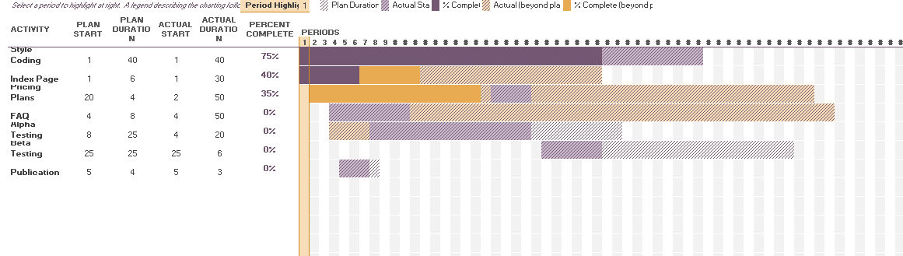

# Quality Control

Because the use of an agile project approach has been utilised throughout the development process. This means that alpha and beta testing will occur during the development process. This testing will occur at different phases during the development process usually after large updates. Alpha testing will be conducted from the start of development until the framework of the website is complete. It will include: squashing ground-breaking bugs, direct owner feedback and different browser testing. While beta testing will be conducted after the completed framework and will include: Public testing, smaller bug fixing and other things not related to the basic functionality of the website. Once all the testing has been completed and the website is ready to be deployed then quality will be assured using the contact the developer sections on the website, these will make it so, if a user does experience a bug they can easily contact the developer and then the developer can fix the issue. The developer will add extra content to the website after development, per the owner’s discretion.

# Scope

## Within Scope

List the things that you **are** responsible for creating as the developer. This might include the pages you will create, such as the homepage or contact page and the features you will create, such as drop-down menus and working buttons.

* 4 Full Webpages (About Us, FAQ, Index/ Home, Pricing Plans,)
* 2 Subpages / Forms (Contact the developer, Contact the Owner)
* Hamburger Menu
* Navigation Bar
* Animations (Link Underlines, Hover Selection)
* Working Buttons
* Redesigned Logo
* Embedded Videos
* Image Placement / Image Carousels with fades

## Outside of Scope

List the things that you **aren’t** responsible for creating as the developer or can’t complete due time constraints. This might include photos which you can take from the internet, or complex features such as an integrated payment system or leader board.

* Some JavaScript elements
* Integrated payment system.
* Payment system security measures
* Images
* Site content (Information on the CRM systems offered)

# Risk Management

|  |  |  |  |
| --- | --- | --- | --- |
| **Risk** | **Likelihood** | **Impact** | **Mitigation Strategy** |
| What is the risk? | What is the likelihood that it will happen? (low, medium or high) | How much of an impact will this have on the project if it does occur? (low, medium or high) | What can be done to reduce the risk of this happening? |
| **File Corruption** | Low | Med | In terms of file corruption really the only thing that can be done, would be to save the file in multiply places. For the coding elements, this has been done in three different places; GitHub (After every lesson), OneDrive (Once a week) and local storage (Every 5minutes), while for the design brief it is also saved in three places: School OneDrive, Personal OneDrive and a local hard drive, these are saved every 5 minutes through auto save. |
| **Lost files** | Low | Med | As stated above the code files and design brief files are all saved in three different places mean that if one is deleted there will always be at least two backup files that can be accessed. |
| **Computer Malfunction / Battery Problems** | Med | Low | Also, stated above, auto save will be used through the coding process, so that there will be no problems with any files being deleted, At most five minutes work will be lost, which is not a big deal. |
| **Visual Studio Crashing** | Low | Low | As stated above the files will be auto saved in many different places. In the case of not being able to reopen the software. The software would have to be deleted and reinstalled and if that does not work, it would need to be taken to IT services to get windows reinstalled. |

List in the table above, the risks that will prevent project completion or impact upon time constraints. Please **DO NOT** list workplace health and safety issues like ‘carpel tunnel’.

*Please remove the explanations from the above table prior to submission.*

# Design Considerations

**Modern Design Principles:**

1. **Hero Images – “**A hero image is a website design term used to describe an oversized banner image at the top of a website. Sometimes called a “hero header”, it serves as a user’s first glimpse of your company and offering because of its prominent placement towards the top of a webpage that usually extends full-width.” (Elgie, 2018) (Optimizely , 2018) Hero images are used to catch the user’s attention with large HD image, and are usually accompanied by some sort of large and unique typography. Hero images will be used within the website by having the users first thing they look at being the product, this entices the user to continue viewing the website and makes them want to consider the specifics on the product found below the image and on other pages on the website. The use of a hero image will make the website more effective in grabbing the user’s attention and providing basic information about the product.
2. **Flat Website Design – “**Flat design is a minimalistic design approach that emphasises usability. It features clean, open space, crisp edges, bright colours and two-dimensional illustrations.” Flat design makes the website look more clean and less cluttered by using elements such as, grids, less text and two dimensional illustrations. An example of this can be seen in the website under the pricing plan section. In the section, each of the different pricing plans will be separated by clean 2D borders that when hovered over they will be highlighted, minimal text will also be used. The grid and animations will help people to see which option is highlighted, while the minimal text and images used will help to draw attention to the text that matters and help to keep the website looking orderly and clean.
3. **Hamburger Menu – “**The hamburger menu or hamburger icon is a name given to the menu icon found in newer programs and websites that hides the traditional [File menu](https://www.computerhope.com/jargon/m/menu.htm).” Hamburger menus on the website will only be shown on devices where the screen resolution is below 650px this will keep the screen less cluttered on smaller screens.

Choose **at least 3** design principles (eg. Jakob’s Law, colour and responsive design) and explain your understanding of each using sources to support your explanations. Finally, explain how each design principle will impact your product.

# Detailed Description of Project

## Navigation

Create a flowchart that demonstrates the navigation between pages within the product. Use a double arrow to show that the user can move backwards and forwards between two pages and a single arrow to show the user can navigate to a certain page, but not backwards to the previous page.

## Concept Roughs

Create concept roughs for **the major pages** of your product along with annotations and alternative designs for elements on the page (e.g. drop-down menu or hamburger menu option).

Underneath each concept rough, provide a detailed description of what the user can do on each page.

**Description for all pages:**

Describe the common elements that will feature across all pages for example the navigation, footer and logo.

**Page 1 Concept Rough:**

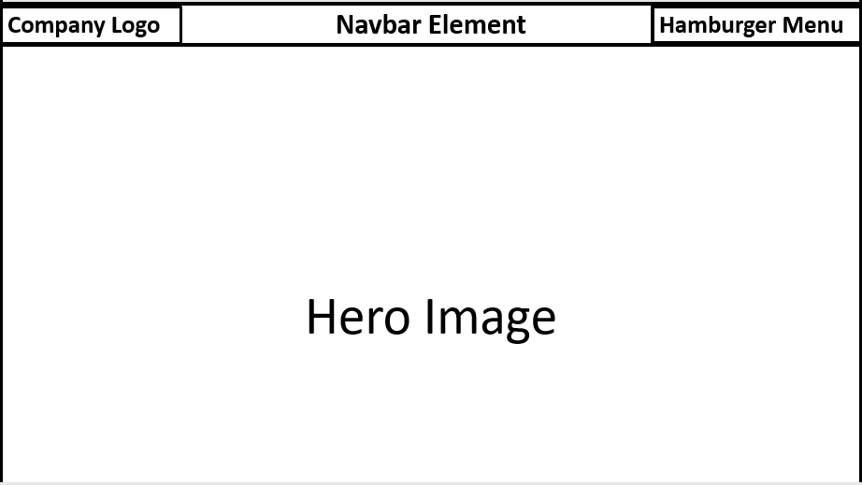

**Page 1 Description:**

There are 3 main elements on the home page, separated into 2 divisions. These are: The Company logo, the hero image and the hamburger menu. The company logo will be in the top left hand corner, it will be used on other screens to navigate back to the home screen this will be inside the navbar element. The navbar acts as a division for placing other elements at the top of the page. The navbar and all elements inside it will be transparent. The hamburger menu will be used to access the main navigation menu across all pages, will be animated and change colours depending whether it is open or closed. The hero image will take up the whole screen and feature a large picture of the product in 4k quality for the most details.

**Page 2 Concept Rough:**

Insert concept rough here.

**Page 2 Description:**

Describe what the user can do on this page.

**Page 3 Concept Rough:**

Insert concept rough here.

**Page 3 Description:**

Describe what the user can do on this page.

# CIPP Evaluation

## Context

The factors that influence planning, design and development.

* Background Information – What was your vision for the product and who created it?
* Environmental Influences – What measures were put in place to assist the developer?
* Client Influences – What was the budget and how did you plan your time to reach the deadline?
* Other Circumstances

## Input

The resources needed to plan, design and develop.

* Physical resources – What hardware and software was used?
* Human resources – What was the developer’s skill and knowledge level?
* Time utilisation – Was time utilised as effectively as it could have been?

## Process

The identifiable phases undertaken in design and development.

* Alignment between design plan and actual development – Did you follow the Gantt chart exactly?
* Effectiveness of development process – Was the planned development phase in your Gantt chart carried out effectively?
* Effectiveness of testing process - Was your chosen project approach effective in terms of testing?

## Product

Review of the outcomes of the solution/product using criteria directly related to the client's requirements.

* Alignment of final product to original design plan - Did the product turn out as planned in your Gantt chart?
* Match of final product to client needs – Does the final product meet the need of your client?
* Effectiveness of final product – Is the final product easy to use and do all elements work properly?
* Future alterations/improvements to the product – What would you have added to improve the product in the future?

# Developer’s Journal

Record what you are working on each day throughout the development phase of your product. You take these notes to compare what you wanted to do each day and what you realistically worked on.

Make **detailed** notes on the following categories:

* Tasks started
* Tasks completed
* Bugs to fix
* Bugs fixed
* Ideas
* Tutorials watched
* Alpha/beta testing

|  |  |  |
| --- | --- | --- |
| **Date** | **Category** | **Explanation** |
|  |  |  |
|  |  |  |
|  |  |  |
|  |  |  |

# 11 References

**There are no sources in the current document.**

Use the *insert citation* option in the *References* tab above to add your sources to the reference list above. Remember to use APA referencing and include in-text citations throughout your design brief.